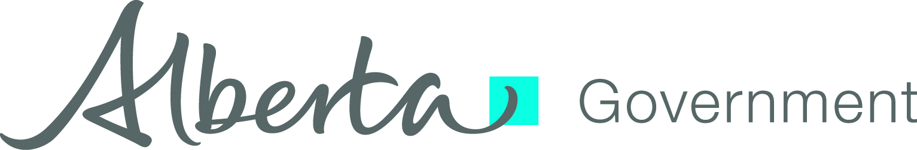
AISH Program Policy Manual Update

Assured Income for the Severely Handicapped

Subject: Payments Issued to Tsuu T’ina First Nation Members Under the Calgary
Ring Road Agreement

Number: AISH-Program-2015-007

Date Issued: June 24, 2015

Effective Date: June 26, 2015

Issuer: Sherri Wilson
Executive Director
AISH Delivery Services

Distribution: AISH Program Policy Manual Update Subscribers

BACKGROUND:

On June 26, 2015 the Tsuu T’ina First Nation is issuing a per capita distribution (PCD) payment to its members. The source of these PCD payments are proceeds received under the Calgary Ring Road Agreement. The Calgary Ring Road Agreement stipulates that payments issued to Tsuu T’ina members will not affect eligibility or reduce availability of funding and programming available from the Government of Alberta (GoA).

The PCD payments are fully exempt as income under the AISH program as these payments are not reportable to the Canada Revenue Agency (CRA).

To honor the Calgary Ring Road Agreement, a request for exempting these payments as an asset must be forwarded to the Director for consideration. When exempted by the Director, the PCD payments will not affect eligibility for AISH, Personal Benefits or the Child Supplement. This also applies to any previous and future payment distributions made under the Calgary Ring Road Agreement.

INTENT:

Update Assets section and Income Type Exemption Table to include information on how these PCD payments are treated under the AISH program.

POLICY:

The following AISH program policy has been amended:

Assets

Income Type Exemption Table

